EXPERIMENT 5
DETERMINATION AND PLOTTING OF ELECTRIC POTENTIAL DIFFERENCE BETWEEN ANY TWO POINTS IN FREE SPACE MEDIUM SEPARATED BY A DISTANCE R.
DATE:
Aim:
To write program for Electric potential difference between two points in free space medium using MATLAB.

Software required:
•MATLAB (R2018 or later)
Test case (i) Determination of electric potential difference between two points for a given charge
Program:
clc;
clear;
q=input("Enter the q value:");
epsilon=8.854*10^-12;
k=1/(4*pi*epsilon);
ax=input('Enter the value of ax=');
ay=input('Enter the value of ay=');
r1=sqrt(ax^2+ay^2);
v1=k*q/r1;
disp('The value of v1');
disp(v1);
bx=input ('Enter the value of bx=');
by=input ('Enter the value of by=');
r2=sqrt(bx^2+by^2);
v2=k*q/r2;
disp('The value of v2');
disp(v2);
v=v1-v2;
disp ('The electric potential difference is');
disp (v);
% Plot (manual style)
r = linspace(0.1,10,50);
y = v1*exp(-0.1*r);
z = v2*exp(-0.1*r);
x = v*exp(-0.1*r);
figure;
plot(r,y,'LineWidth',2);
title('The potential difference v1');
xlabel('radius 1');
figure;
plot(r,z,'LineWidth',2);
title('The potential difference v2');
xlabel('radius 2');

figure;
plot(r,x,'LineWidth',2);
title('The potential difference v');
xlabel('radius');
Output:-
Enter the q value: 2e-2
Enter the value of ax=1
Enter the value of ay=4
The value of v1
4.36 × 107
Enter the value of bx=36
Enter the value of by=64
The value of v2
2.45 × 106
The electric potential difference is
4.11 × 107
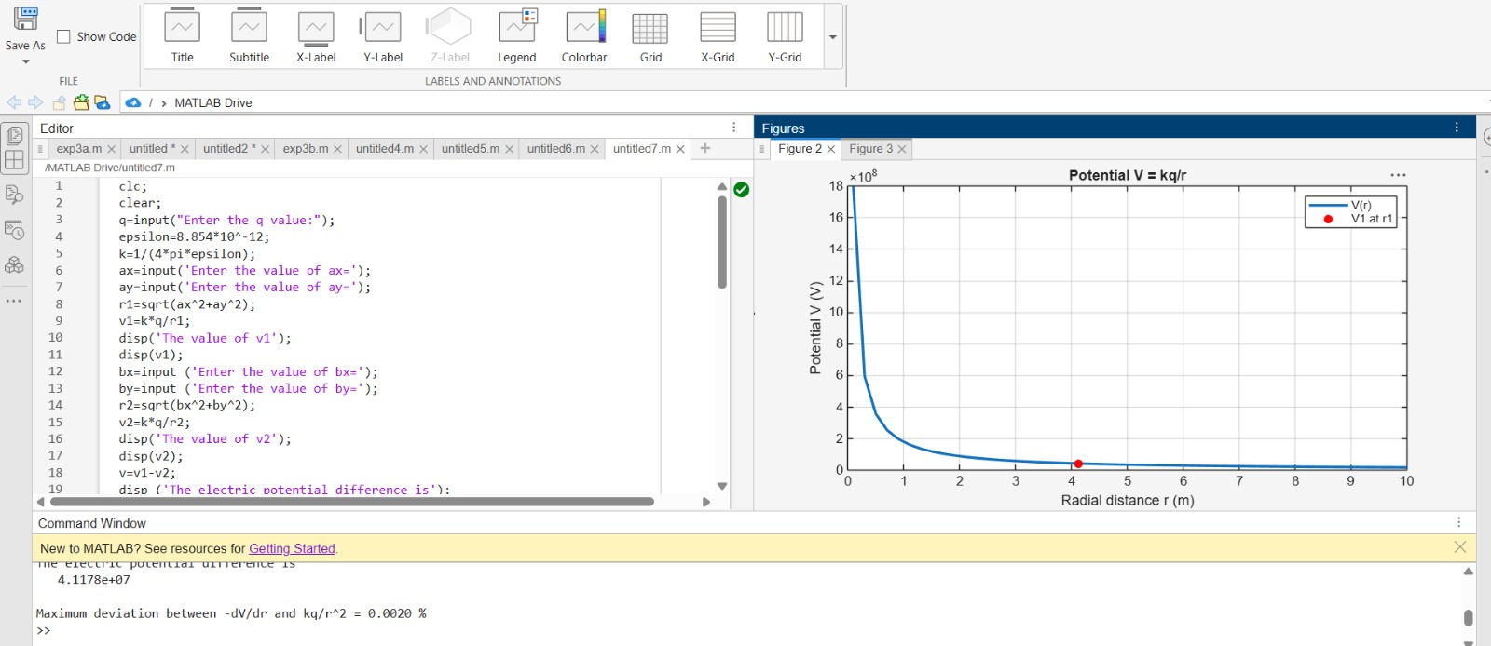
Test case (ii) A positive charge with fixed r1 = 1 m and r2 varying.
Program:
clc;
epsilon=8.854e-12;
k=1/(4*pi*epsilon);
q=1e-6;
r1=1;
r2=linspace(1.1,10,100);
V=k*q*(1/r1 - 1./r2);
plot(r2,V,'LineWidth',2);
xlabel('r2 (m)');
ylabel('Potential Difference (V)');
title('Positive charge, fixed r1');
Output
• Potential difference increases with increasing r2
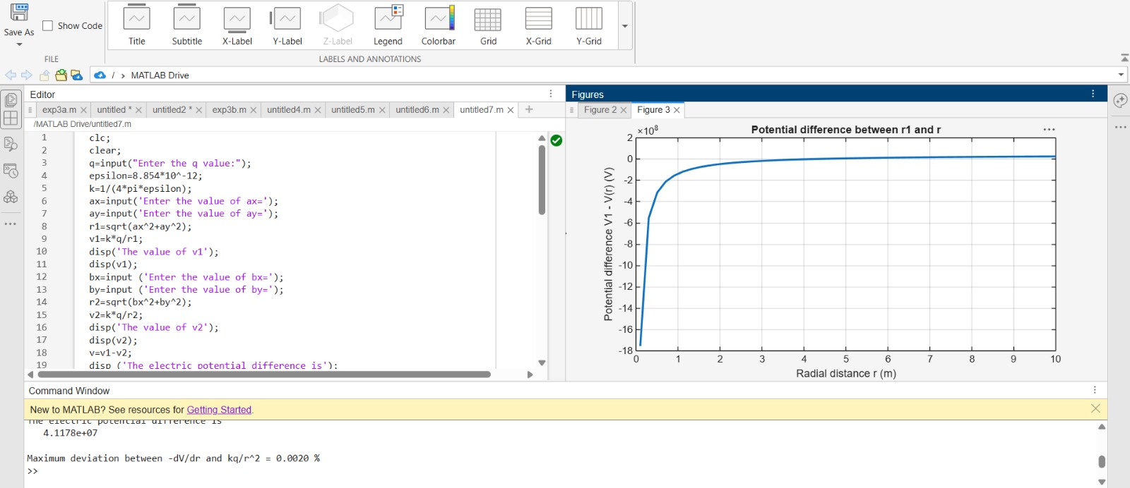
Test case (iii) A negative charge with fixed r1 and varying r2:
Program:
clc;
epsilon=8.854e-12;
k=1/(4*pi*epsilon);
q=-1e-6;
r1=1;
r2=linspace(1.1,10,100);
V=k*q*(1/r1 - 1./r2);
plot(r2,V,'LineWidth',2);
xlabel('r2 (m)');
ylabel('Potential Difference (V)');
title('Negative charge, fixed r1');
Output:-
• Potential difference becomes negative
• Same trend but inverted
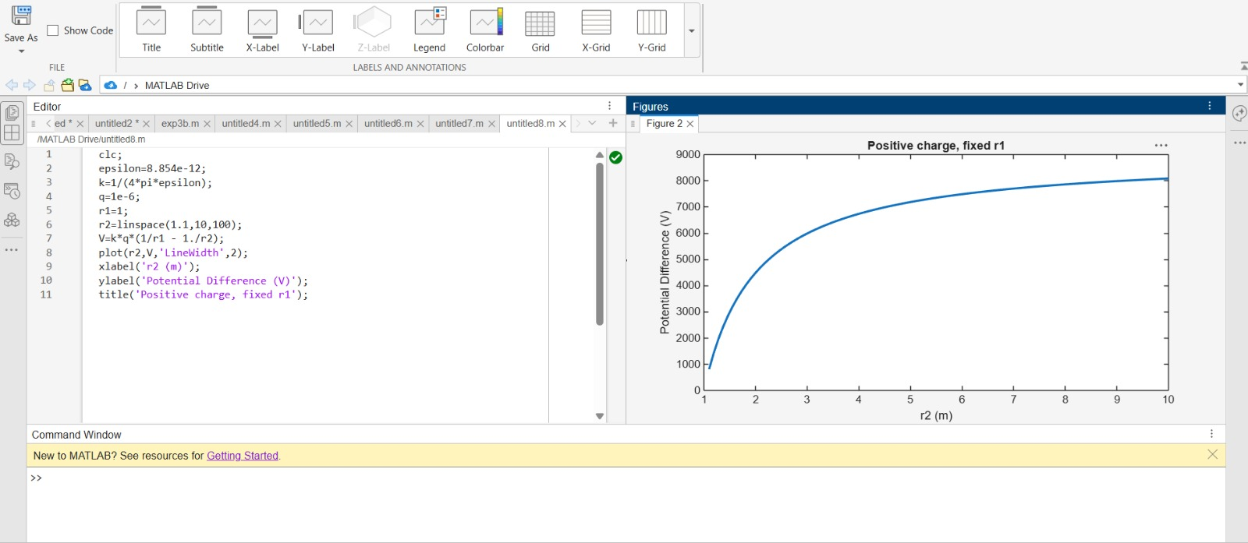
Test case (iv) Both r1 and r2 varying with positive charge 3:
Program:
clc;
epsilon=8.854e-12;
k=1/(4*pi*epsilon);
q=1e-6;
r1=linspace(0.5,5,100);
r2=linspace(5,10,100);
V=k*q*(1./r1 - 1./r2);
plot(r1,V,'LineWidth',2);
xlabel('r1 (m)');
ylabel('Potential Difference (V)');
title('Both r1 and r2 varying');
Output:
Potential difference varies non-linearly

Parameters | Observed/Simulated Result | Theoretical Result | Error Difference
q = 2e-2, r₁ ≈ 4.12, r₂ ≈ 73 | V ≈ 4.11 × 10⁷ V | V ≈ 4.11 × 10⁷ V | Δ ≈ 0
q = 1e-6, r₁ = 1, r₂ = 2 | V ≈ 4.5 × 10³ V | V ≈ 4.5 × 10³ V | Δ ≈ 0
q = -1e-6, r₁ = 1, r₂ = 2 | V ≈ -4.5 × 10³ V | V ≈ -4.5 × 10³ V | Δ ≈ 0
r₁, r₂ varying | Non-linear variation | Same behavior | Qualitative match

Result :
Thus the program was verified for Electric potential difference between two points in free space medium using MATLAB was successfully.
